HeadShop 11 PRD

This is the next version of a full HeadShop DAZ plugin software.

The main focus of this release is to take advantage of the Luxand SDK with smile **and** apply it to photos that are not 100% straight but may be turned 20 degrees +/- in any direction. (It may work on some pictures and not on others.)

Opening screen opens for picture selection. NOTE: we won’t need Good/Bad pictures, all picture should be good. Only restriction is that pictures rotated <20 degrees will be warned and rejected. All images will be scaled and output to 4096x4096 texture resolution.

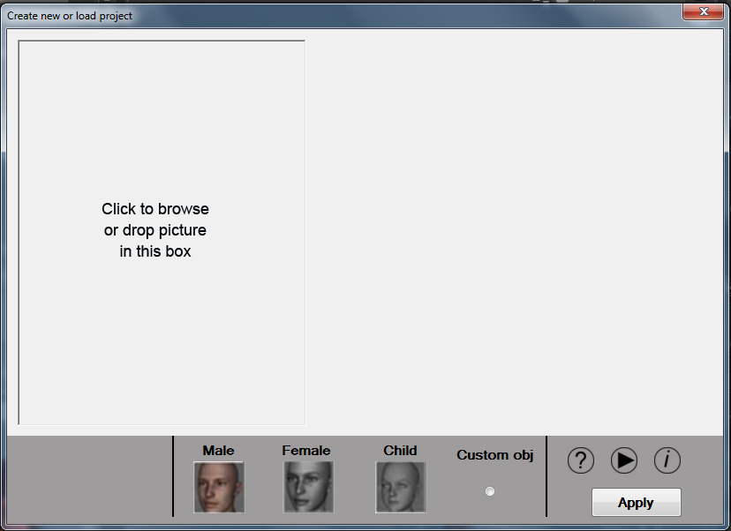

Like with OneClick, we do not show the Luxand dots. Instead, user can choose Male, Female or Child or – Custom obj (VERY IMPORTANT!). User clicks Apply.

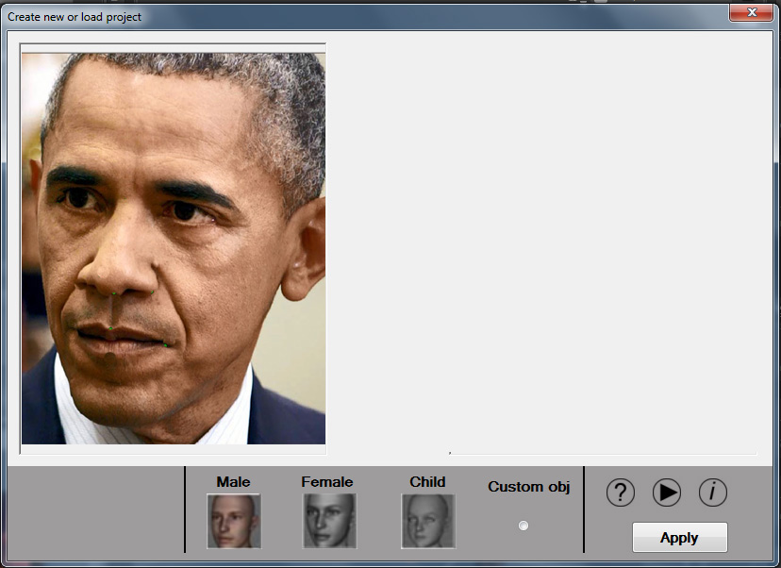

Stage 1. (**ALREADY DONE in January 2017**)

I realize that this is not easy to do. It is possible, as we have done this with earlier software that was a Photoshop plugin. At that time the picking of the point was manual and very time consuming. With the Luxand points it should be easier and faster to do.

My proposal is to accomplish this in 3 stages (see movie Obama2)

Stage 1. Rotate the head based on Luxand dots ($250)

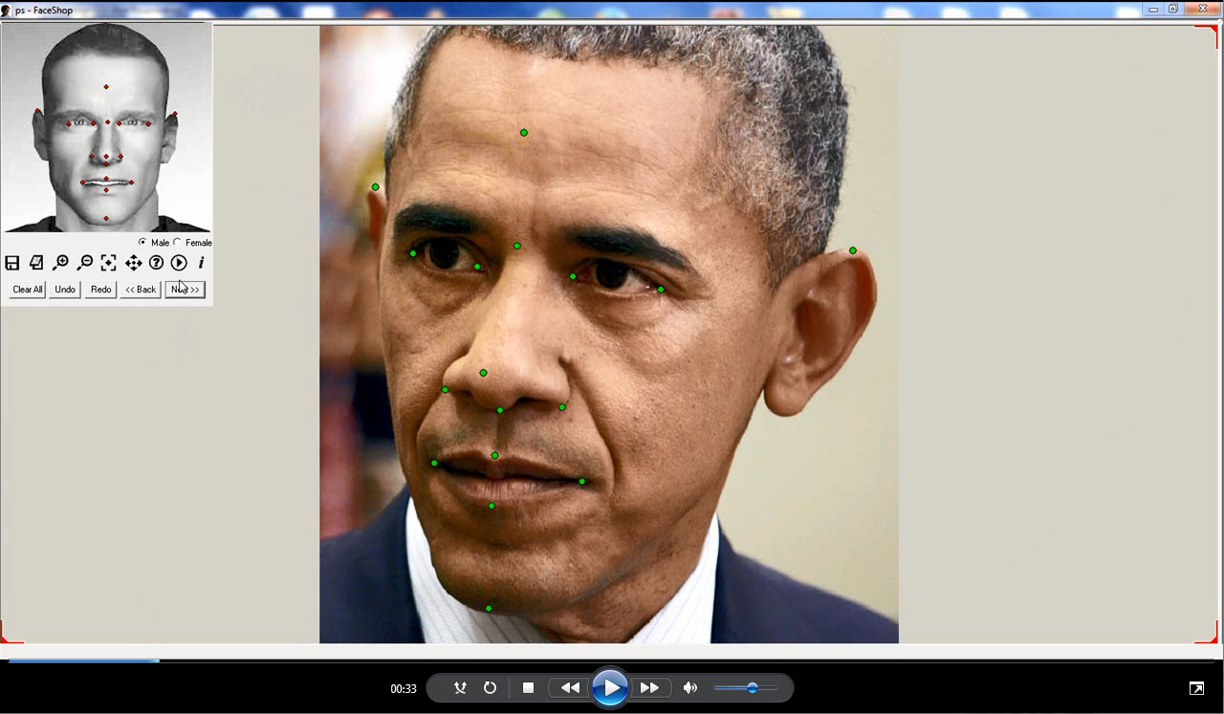

This screen shows how the software picks the strategic points manually and rotated the head.

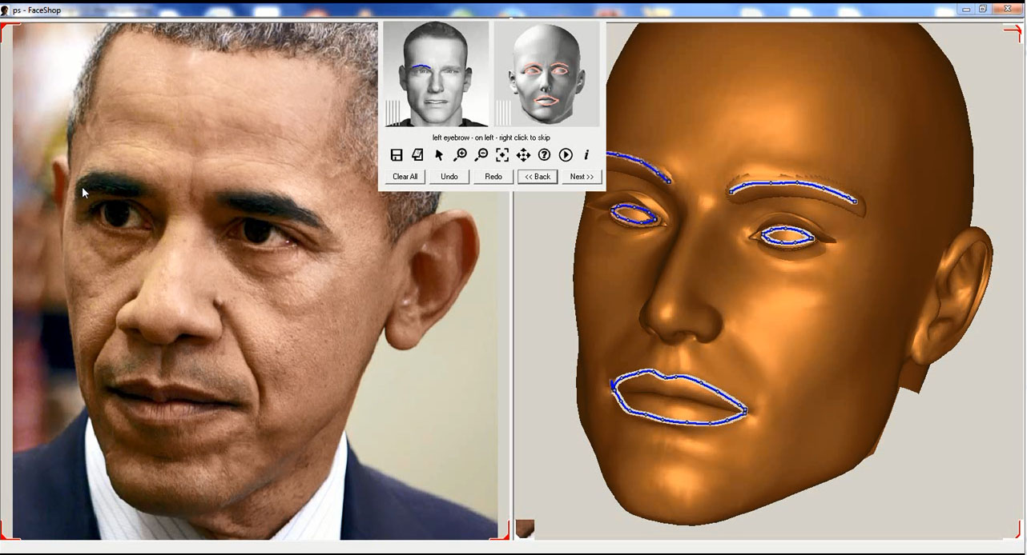

Stage 2 ($400)

This is the hart part – mesh deformation. Based on the Luxand points the mesh is deformed. (In the old software this was manual).

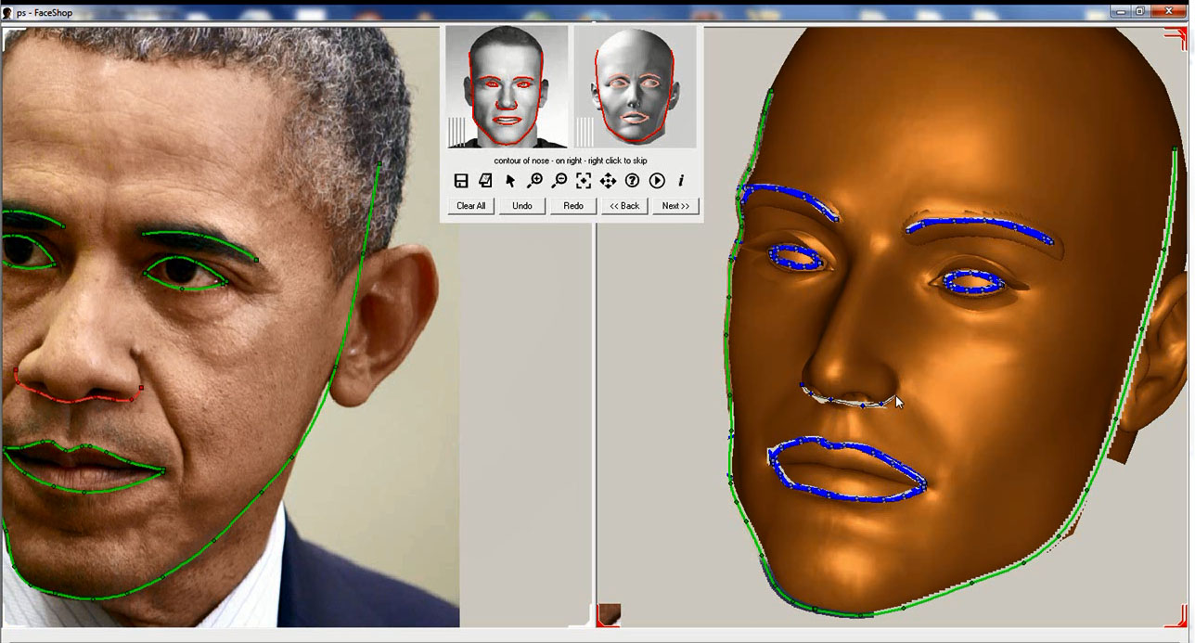

Resulting in deformed mesh

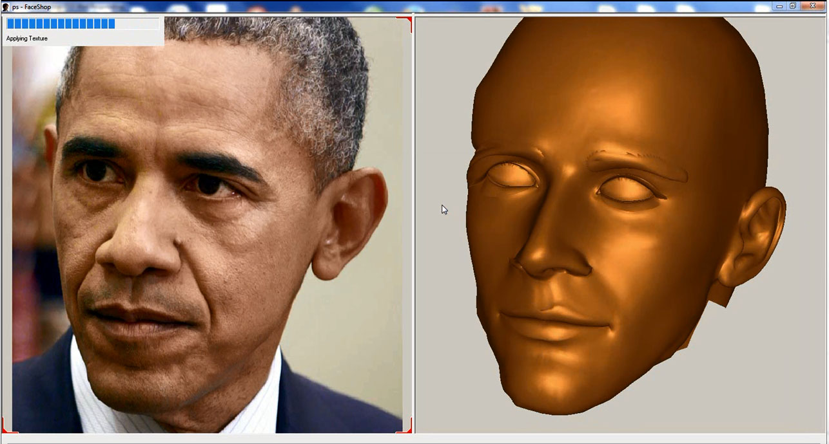

Stage 3. Mirroring mesh and texture ($350)

In this stage we take the good side of the mesh and mirror it over to the opposite side.

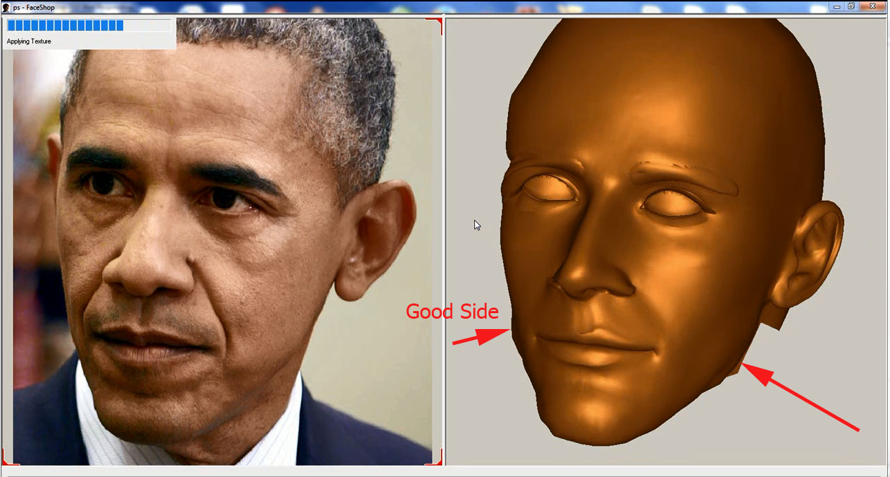

Take the good texture side and mirror it to the opposite side

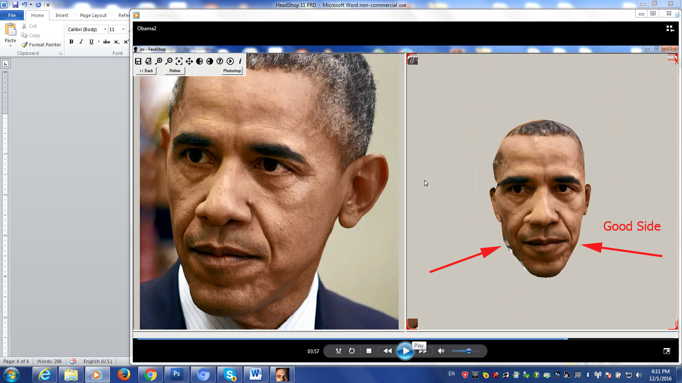

The resulting head should have good shape and better texture information than current

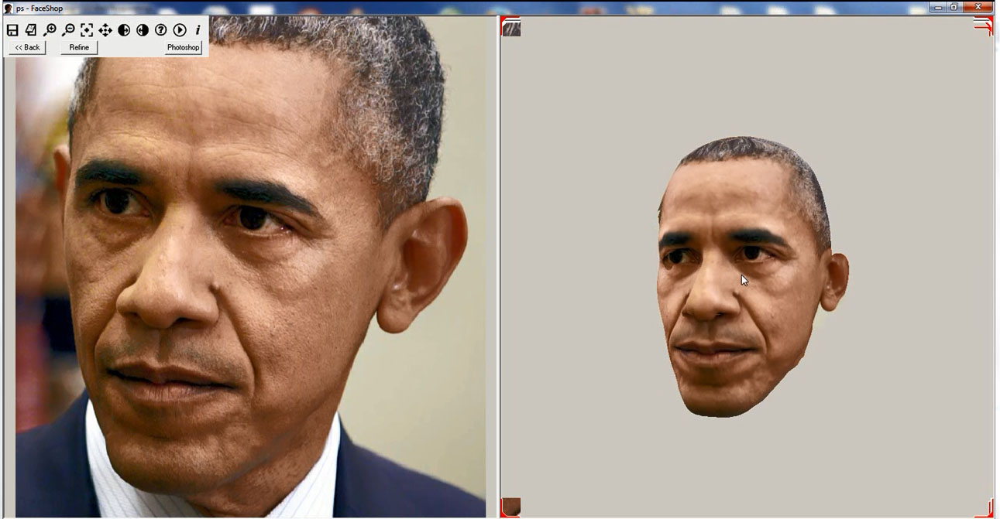

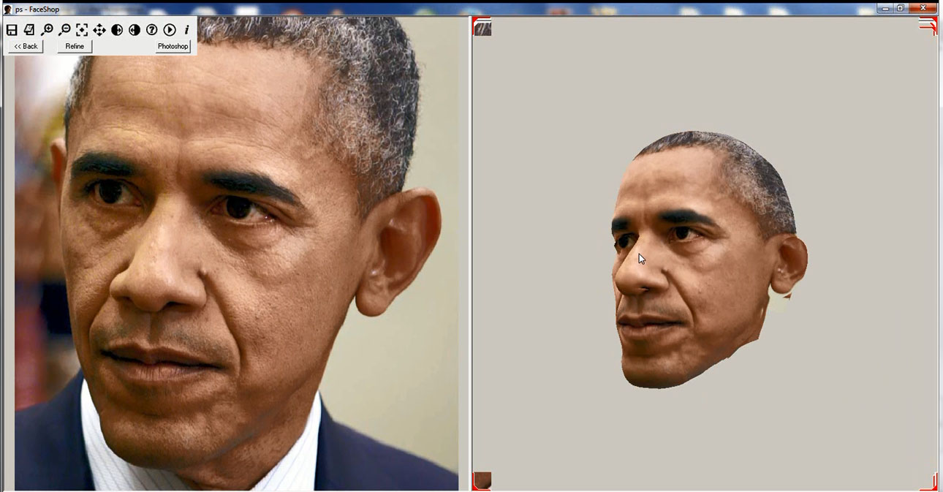

Everything else in interface stays unchanged.

The only exception is that we delete the Color 3D option on Stage tab.

